Design, Construction and Evaluation of an

Accurate, Low-Cost Portable Production Tester

Final Technical Report

For Time Period:

1 September 2004 to 31 December 2005

by
Principal Authors:

Kenneth D. Oglesby, PE and Parviz Mehdizadeh, Ph.d

Report Issued:
31 January 2006

DOE Prime Cooperative Agreement to Penn State:
DE-FC26-04NT42098
Subcontract to Oak Resources, Inc.:
2775-ORI-DOE-2098

Submitting Organization: Oak Resources, Inc./
Impact Technologies LLC
P. O. Box 35505
Tulsa, Oklahoma 74153-0505

Significant Sub-Contractor : Production Technology Inc. 14225 North 99th Street
Scottsdale, Arizona 85260

Disclaimer Page:

This report was prepared as an account of work sponsored by an agency of the United States Government. Neither the United States Government nor any agency thereof, nor any of their employees, makes any warranty, express or implied, or assumes any legal liability or responsibility for the accuracy, completeness, or usefulness of any information, apparatus, product, or process disclosed, or represents that its use would not infringe privately owned rights. Reference herein to any specific commercial product, process, or service by trade name, trademark, manufacturer, or otherwise does not necessarily constitute or imply its endorsement, recommendation, or favoring by the United States Government or any agency thereof. The views and opinions of authors expressed herein do not necessarily state or reflect those of the United States Government or any agency thereof.

ABSTRACT:
A portable oil and gas production well tester was designed, proved and tested in the field on 35 wells in over 100 separate tests. It answered fundamental accuracy concerns and identified areas of improvement required. This generation tester was more expensive than planned, but it has pointed the way to lower cost next generation testers. With modifications identified, it can be the required evaluation tool needed for designing additional field specific testers.

TABLE OF CONTENTS:
Abstract…………………………………………………………3
Table of Contents……………………………………………….3
List of Graphical Materials…………………………………… .3
Executive Summary…………………………………………….4
1- Introduction ……………………………………………...5
2- Need for PWT……………………………………………6
3- Multiphase Testing Theory………………………..…….10
4- Design of the PWT…………………………………..…..10
5- Fabrication……………………………………………….12
6- Calibration and Proving Tests…………………………...13
7- Unit Setup and Mobility…………………………………19
8- Data Communication…………………………………….26
9- Field Tests- General Observations……………………….31
10- Analysis of Field Tests…………………………………...33
11- Conclusions ……………………………………………....42
12- References………………………………………………...44
13- Acknowledgements……………………………………….44
14- Appendices………………………………………………..45
A. Summary Table of detailed Tester activities for all wells.
B. Individual Well Plots of Modbus data
C. Table of all Calibrations used in the testing
D. Table of RE2G readings versus sampling WC values
E. Table of Rate and WC readings with and without GLCC
F. Table of variable Calibrations Impact on WC readings

LIST OF GRAPHICAL MATERIALS:
- Photograph of Designed & Constructed PWT in the Field
- Typical Low-Cost, rate Only Meter & Hose Testing Setup
- Schematic of PWT without trailer
- P&ID of PWT with Major Components
- PWT at University of Tulsa Test Flow Loop
- PWT at Weatherford Test Flow Loop
- Water centrifuge pump at Weatherford Facility
- Proving Coriolis Meters at Weatherford Facility
- Proving Results for Vortex Gas Meter
- Well Samples being centrifuged for RE2G Calibration
- PWT Field Calibration equipment
- PWT in Transport Mode
- PWT in Test Mode
- PWT close up in Test Mode
- Idealized Wellhead Testing Header
- Central Test Header setup
- RTU touch Screen
- Communication Methods for Testing
- RE2G & Operator Watercuts versus Sampled Watercut
- PWT rate versus Operator Reported Rate
- PWT Watercut versus Operator Reported Watercut
- Impact of GLCC Bypass on Rate
- Impact of GLCC Bypass on Watercut
- Calibration Sensitivity on Watercut

EXECUTIVE SUMMARY
Current testing methods for high volume and high water cut wells are not very effective in providing accurate oil, water and gas production information. Such information is important in providing a basis for making good decisions on these wells to obtain lower cost and higher production. To this end, a portable oil and gas production well tester was designed, proved and tested in the field on 35 oil wells in over 100 separate tests. These tests evaluated the accuracy of the Tester, the need for separation of the well fluids before metering and the calibration level needed for accuracy. It answered these fundamental questions and it identified areas of improvement required. This Tester was not as inexpensive as planned nor as easy to fabricate and prove, but it has pointed the way to lower cost for the next generation of testers planned. With modifications identified for this Tester, it can be the evaluation tool needed for designing these field specific testers.

1- INTRODUCTION

This is the final report for this Project that summarizes the activities conducted, results obtained and conclusions drawn. The major objectives of the project were:
- Design and construct a prototype of an accurate, affordable portable well testing (PWT) system to overcome the shortcomings of the conventional tank and port-a-check measurement systems.;
- Test the performance and stability of the system and its components;
- Establish the capability of the different configurations of the system for testing wells;
- Propose a “next generation” configuration suitable for the next phase (phase 2) of the project on the basis of findings in items 1-3 above.

The original Project activities were outlined by Tasks as follows:
- Research and Evaluation
- Design, Selection and Purchase
- Initial Fabrication
- Final Fabrication
- Field Testing
- Final Evaluation

Activities in support of Objectives 1 were listed as Tasks A and B in the project scope of work. These activities were completed and reported in reference 1. A prototype system was fabricated in Impact’s shop and tested at the University of Tulsa’s Flow Loop and in preliminary field tests in the Glenn Pool field during the June-July, 2005 time period, per Tasks C&D of the project scope of work. These results were reported in reference 2. These initial loop and field tests revealed a number of shortcomings in the performance of the system. Revisions were made to the system during August-October, 2005 to address these shortcomings and the PWT was subsequently tested in the Weatherford loop in Houston during October - November, 2005 to evaluate the impact of the revisions. This work accomplished Objective 2. Following the evaluation of these additional loop tests the system was returned to the field for additional well testing during November – December, 2005. The results of these well tests, as well as all the activities conducted within the project, are reported, reviewed and analyzed in this final report as required by Tasks E to F of the project scope of work- settling Objective 3.

This Portable Well Tester (PWT) project has carried out more than 90 well tests plus about 30 flow loop tests to provide the data used in this final report. Over 35 different wells were used in the field tests – many wells had multiple tests with different PWT configurations and instrument settings. The objective of varying the PWT configurations was to find if “simpler” and cheaper hardware configurations could provide accurate data and reduce the cost of next generation PWTs. Varying the instrument settings allowed investigating the sensitivity of input variables to the rate and water-cut outputs.

The infrared absorption technique was used for water cut measurement in the PWT, but required calibration of the system to accommodate produced fluids from different wells (i.e., this is a portable unit). Thus a number of well tests on the same well were run with different (oil and water) calibration inputs to assess the sensitivity of the water cut measurements to well fluids.

The PWT uses a centrifugal type separator (GLCC) to separate the liquid and gas. A number of tests therefore involved same well flow streams with and without the use of the GLCC to establish the response of the PWT to different wells and lift methods.

Table 1, in Appendix A, summarizes the general testing activities that were carried out to complete this project. Figure 1 shows the completed PWT testing a well.

2- need for PWT

Secondary Recovery methods, primarily waterflooding, provide approximately 50% of the oil production in Oklahoma. Secondary and Tertiary Recovery methods also provide a significant amount of production in other states. These type operations typically handle large volumes of water, small volumes of oil and, sometimes, natural gas. In addition, the Hutton, Bartlesville and Arbuckle formations also produce large amounts of water with small amounts of oil and gas under primary production. Accurate testing of such wells is important to determine reserves, the economics of continued operations and to evaluate projects (recompletion, gel polymers, horizontal laterals, and other actions on a well as well as implementation of advanced recovery methods) to improve oil and gas production and/or reduce water production- either means to increase well profitability and reserves. There is no substitute for good accurate data on which to base these decisions and actions.

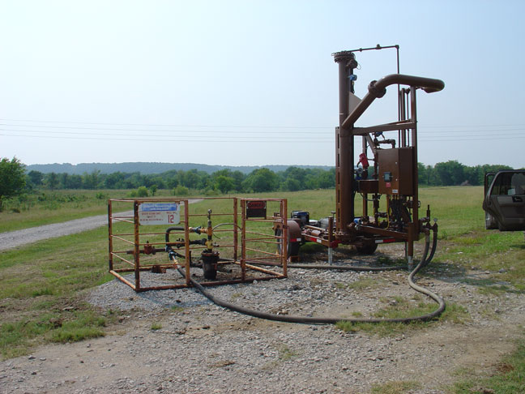

Figure 1- Designed and Constructed PWT in the field.

For example, in the targeted high volume, high water cut (low oil cut) wells, any error is magnified onto the amount of oil that can be sold (i.e., $ revenue). In these wells, only a small 1% change (e.g., 98-99%) can make the difference between a decent well and a money loser. For example, a 1000 bpd (liquid) rate well selling crude oil at $50/ bbl oil price, paying 3/16 royalty and 7% severance tax to the state, with operating costs of $0.20/bbl (variable cost) and $400/well (fixed cost) the economic result are-
98% water cut for a $147.5/ day profit
99% water cut for a $226.0/ day loss
Thus, accurate measurements are essential for decision making on these wells.

Production well testing is currently done by centralized separation and metering stations, portable testers or portable tanks. Centralized systems are expensive and require extra equipment to be installed and maintained over their entire lives. This results in increased long term costs and environmental risks. Portable well systems allow testing at the individual wells or a centralized site and do not require additional permanent equipment to be installed and maintained at each site. Portable tanks are good for low volume wells, but are difficult to move, setup and can overflow for higher volume rate wells. Low cost portable testers ($10,000+) are not accurate enough, due to sampling frequency and gas interference. Other low cost portable test methods, such as using a hose and turbine meter seen in Figure 2, are low cost but inaccurate due to gas interference and do not give water-cuts. Higher accuracy portable units range in cost from $50,000 to $100,000 and are out of the economic reach of most independent operators. Also, many wells do not have electricity available on site. Thus, most stripper well operators must accept poor accuracy in portable testers.
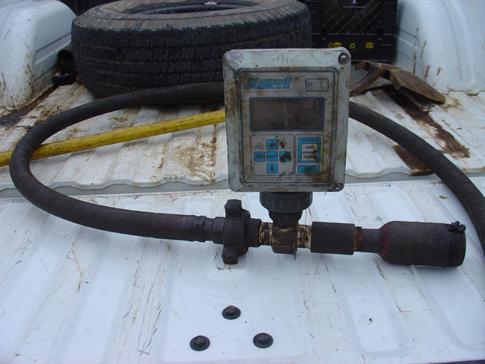

Figure 2- Typical Low-Cost, Rate Only Meter and Hose setup

Current conventional well testing accuracy for determining the oil and total fluid flow rates can range from ±5% to ±50%. In addition, the amount of time, labor and cost needed to perform well testing, using conventional gravity based test separator or tank gauging causes the operator to perform well testing infrequently. These two factors combine to produce well test rate data with great uncertainty and inconsistency that results in allocation factors (sum of test / sales ) that vary from 0.65 to 1.25.

This project’s primary objective was to find a suitable solution to this dilemma - i.e. a PWT that is accurate and affordable. At the beginning of this project, it was understood that the optimum (cost, size,…) tester would not be designed in this first attempt. A secondary objective of this project was to configure a system that would reduce the test time and labor, thus allowing operator to increase the frequency of well tests.

3. Theory of Multiphase testing
The theory and design of multiphase metering was thoroughly discussed in the original proposal and in the earlier Status Reports (1) (2). In this project we were impressed with the improvements in metering that has occurred in the last few years. Delays in the early (Tasks B and C), in selecting and purchasing the meters and instruments, was accepted to obtain the newest generation meters for rate and watercut. These later generation meters can tolerate gas contents that would cause early meters difficulties and errors in measurements. The GLCC was only used to verify the level of separation that was needed with these meters.

4. Design of the pwt

The PWT specification and design (Tasks A&B) work was reported in reference 3. A summary of the design is shown in Figures 3 & 4 and Table 2. The liquid, WC, and gas handling capability of the system, its performance envelope, and vendor specified range and accuracy are listed in Table 3. Requirements of the system were: height clearance of less than 7 ft or near the height of pickup cab, high bottom clearance for rough roads, width near the width of a pickup truck, weight limit of 5000# to be pulled by a regular ½ ton truck capacity, easy for a one man setup. The unit was designed to be able to test a wide variety of wells from 15-40 API, liquid flow rate range of 100 to 1500 BPD, gas flow rate range of 0-75 mcfpd, and 0-100% watercut.

In Figure 3, the side view of the PWT shows major components. The red section shows the equipment needed in possible Next Generation Testers. Figure 4 shows that the well’s flow stream can be directed through the upper branch to the GLCC for gas liquid separation. The separated liquid is discharged from the lower liquid port of the GLCC into the Coriolis mass liquid meter and the RedEye2G water cut meter to measure the liquid rate and watercut. The gas exits the top of the GLCC and is measured by the Vortex meter. Alternatively, the GLCC can be bypassed and the entire flow stream directed into the liquid leg and through Coriolis and RE2G WC meter. The two DE-electric control valves, designated as LCV109 and GCV109, provide the liquid level control for the GLCC.
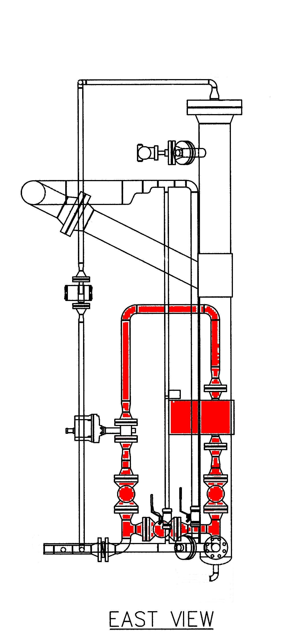

Figure 3- Portable Well Tester schematic without trailer. Red section indicating possible Next Generation Tester equipment.

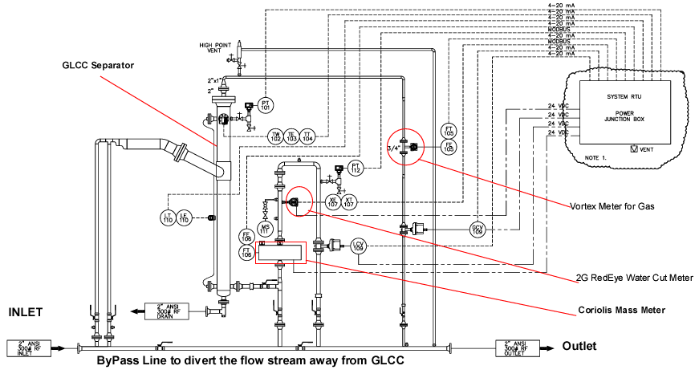

Figure 4- P&ID of the PWT showing major components of the system.

5. Fabrication
After design, specification and purchase of the equipment, instruments and supplies, the trailer and unit was fabricated by Impact Construction at their shop near Tulsa Oklahoma. Welding, threading and victraulic connections were used in this fabrication process. Picture of the construction stages can be seen at www.impact2u.com/projects. The unit was built to ANSI 3000 specifications. The unit (GLCC, piping and hoses) was hydraulically pressure tested to 600psig before proving or field testing.

Wiring of the instruments was performed by eProduction Solutions/ Weatherford in their Kingwood facility.

6. Calibration and Proving Tests

Two types of calibration tests are normally conducted on multiphase metering devices such as the ones incorporated in this project. The first type is the calibration of device against known and controlled flow conditions. These types of tests are necessary in order to verify or revise the actual performance of the hardware against the vendor specified performance. A second type of calibration is often necessary to adjust the hardware for fluid properties - i.e. crude gravity and produced water salinity that are specific to well locations. This type of calibration may have to be performed when data on fluid properties have to be entered into the device in order for the device to function properly.

Several sets of type 1 calibration tests were conducted on the PWT to assess the actual performance of the different components for flow rate and water cut measurements under controlled conditions. The initial set of tests were conducted at the University of Tulsa flow loop during June-July, 2005, using air and water as the fluids. Figure 5 shows the set up for this test. These preliminary tests indicated that the liquid rate accuracy for the PWT varied in the 5-8% range. The gas rate accuracy was 5-10% range. These levels of accuracy for liquid and gas rates determinations were judged to be acceptable. These results were reported in reference 1. Unfortunately most of the TU test loop time had to be devoted to trouble shooting the functionality of the level control equipment for the GLCC separator and the internal setting for the Vortex and Coriolis meters, rather than getting more comprehensive data collection on the accuracy of measurements. As a result, additional flow rate calibrations had to be conducted later- after the PWT was taken to the field for its initial field evaluations. These additional calibration tests were conducted at the Weatherford shop in Houston, Texas (Figure 6) and Impact’s facility near Tulsa during September –November, 2005. The results of these proving tests are shown in Table 4 and Figure 9.

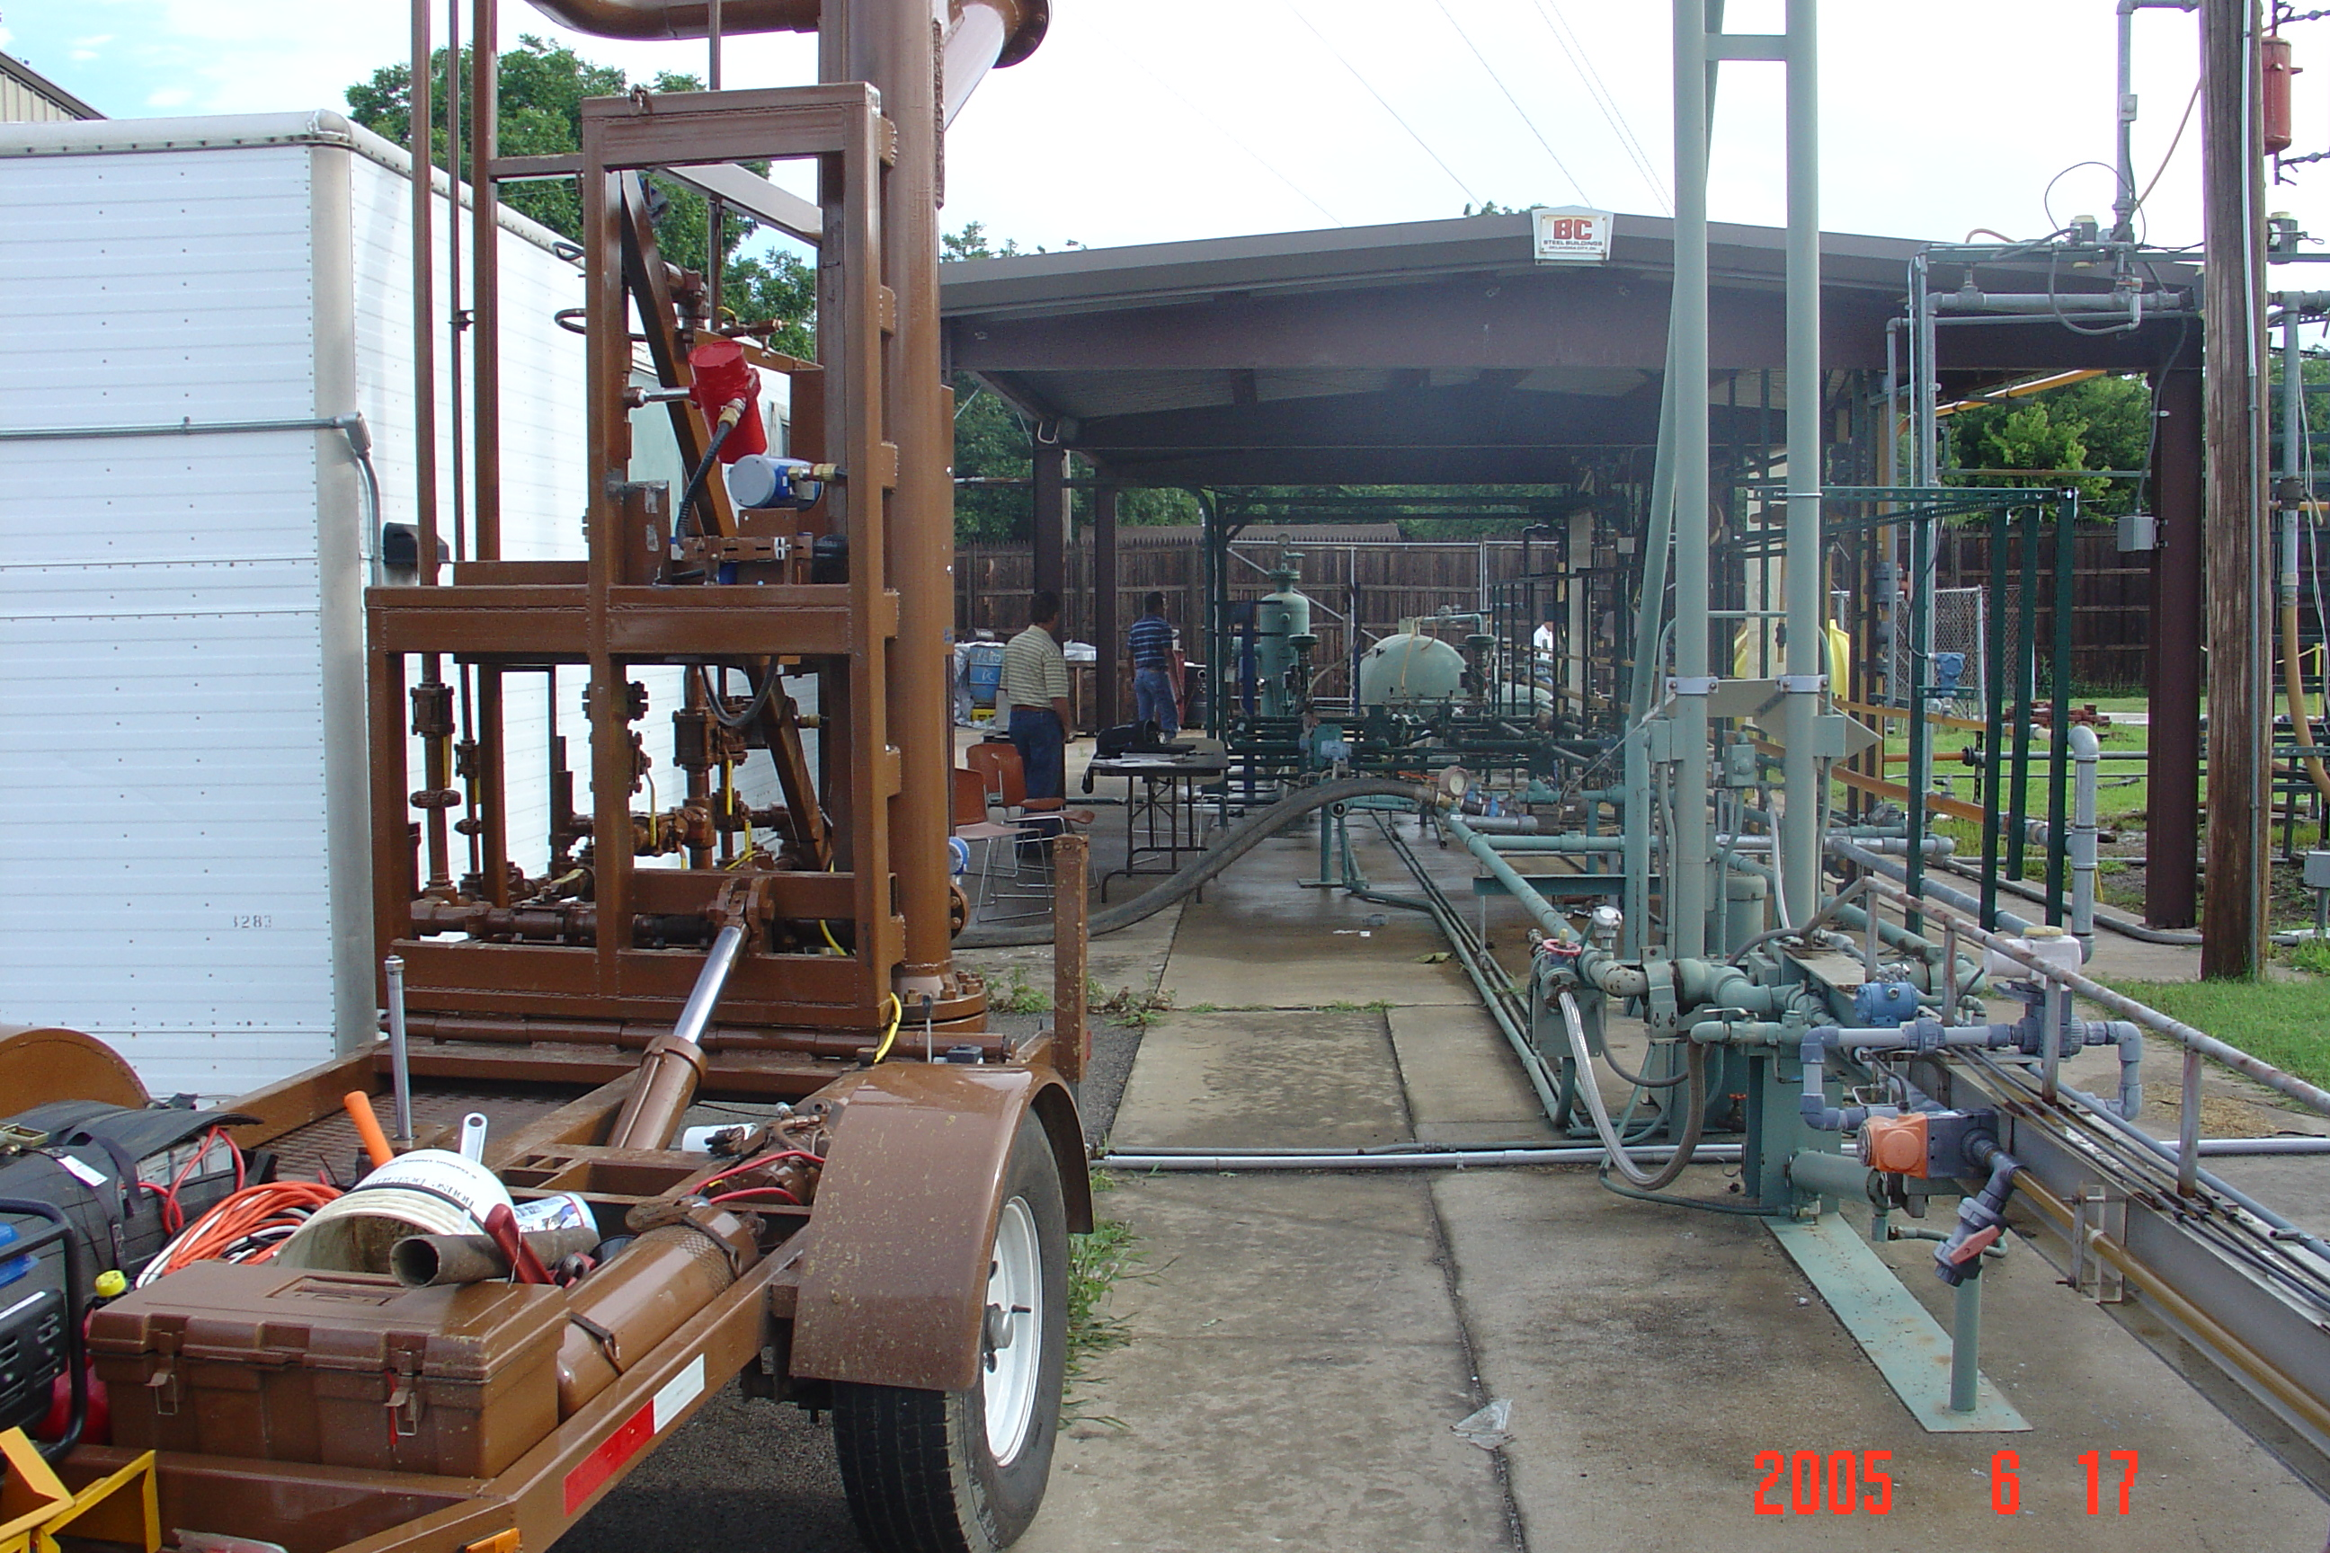

Figure 5- The PWT (left foreground) connected to the test loop at the University of Tulsa for the initial performance and equipment functionality checks. The flow loop used water and compressed air as test fluids.

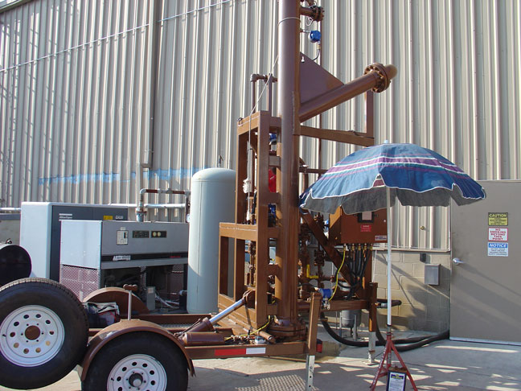

Figure 6- The PWT at the Weatherford Test Flow Loop Facility in Houston TX.
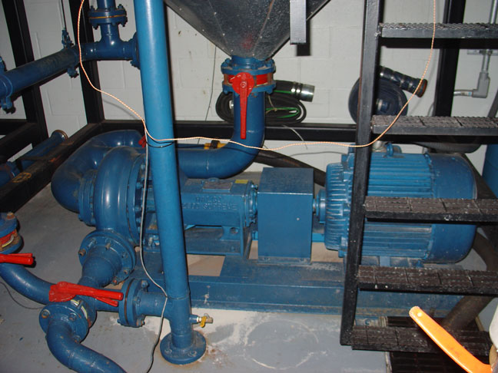

Figure 7- Water centrifuge pump used in the Weatherford Test Loop
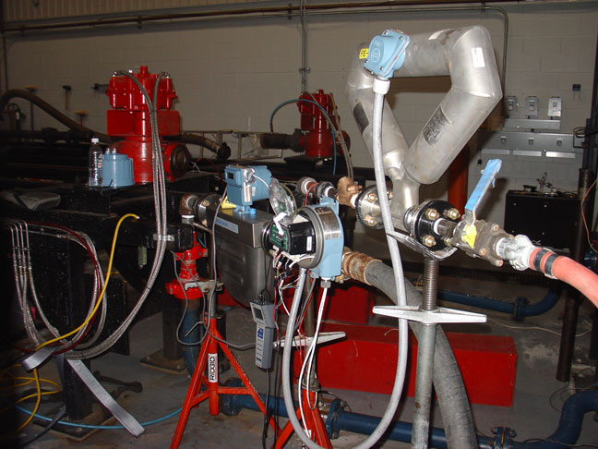

Figure 8- Liquid (bottom 2) and gas (top) coriolis meters used at Weatherford Test Loop

The type 1 flow rate proving and calibration activities consumed months of the project time and was complicated by the following issues:
- Gathering adequate data base on accuracy measurements to build confidence in the PWT rate instruments/ meters.
- Establishing the functionality and the procedures for level control in the GLCC using the electrically operated control valves designed into the PWT.
- Resolving the differences in the universal (default) settings for fluid properties - i.e. density, compressibility etc - between devices made by different manufacturers.
- Resolving data conversions (PVT) settings - i.e. reporting of SCF of gas vs. actual cubic feet of gas - between individual devices and the data acquisition (RTU) system for the PWT.
- Shop repair of Coriolis transmitter
- Repair and proving of Vortex meter
- Interruption of the calibration tests at the Weatherford Facilities in Houston by hurricane Rita. This required test set up to be redone and test data repeated.

In retrospect, these problems could have been resolved much easier had the PWT been subjected to more lengthy and rigorous loop testing initially at the manufacturer’s or other test facilities. Figure 9 shows the results from the November, 2005 calibration proving tests of the Gas Vortex meter versus the Orifice plate meter. Part of the error seen in the calibration plot may be due to the fluctuations in the pressure. Data obtained by controlling the pressure with the upstream valve has less error and is more representative of the PWT accuracy, than the downstream valve control. However, even then, most of the data falls within the ±5% accuracy level.

Type 2 calibrations were and will be ongoing events. In the case of PWT, the RedEye 2G (RE2G) water cut meter uses the absorption characteristics of oil and water/ gas to measure the water cut. This means that absorption coefficients for oil, water and gas have to be inputted into the device as default values or the device has to be calibrated when the fluid properties change. In the case of portable well testing we are moving from well to well and often from field to field. It was, therefore, necessary to conduct specific

Table 4 - Summary of Liquid and Gas Calibration Tests for PWT

Location and Date | Liquid Rate Range  BBL/D | Liquid Rate Accuracy - % | PWT Gas Rate  SCFD | Gas Rate Accuracy - %
Weatherford, Houston  Sept. 20-21, 2005 | 200-1500 | 2-4 | NA | NA
Impact Tulsa  Oct-Nov. 2005 | NA | NA | 17000 - 45000 | 5-10

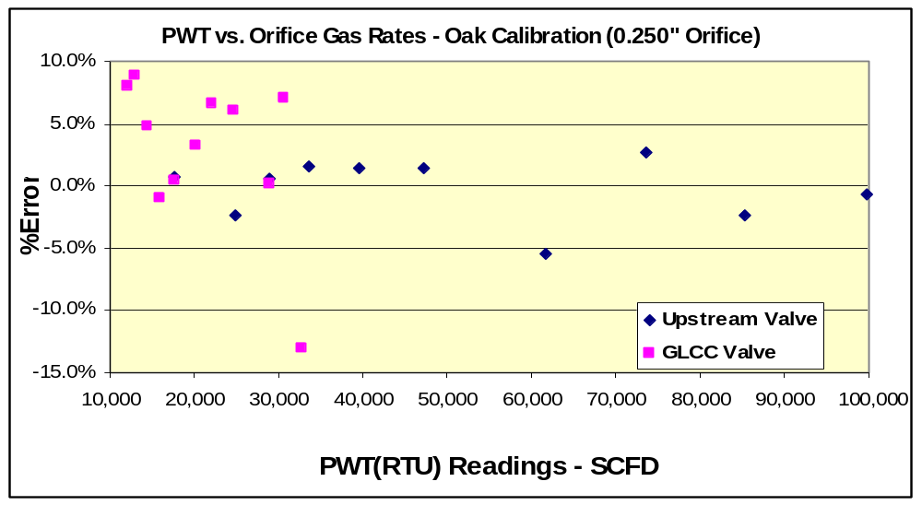

Figure 9- Proving Results from Nov05 calibration of Gas Vortex vs. Orifice meter.

calibrations of the RE2G in order to improve its accuracy for each well to establish how sensitive the device was to changes in fluid properties. Over all, during the field tests for this project we conducted about 31 crude and 14 produced water calibration tests on the RE2G water cut device to obtain fluid characterization for the different wells and fields. A spare RE2G meter was provided by eProduction Solutions for this purpose, since calibrations could not be done ‘insitu’ in the current PWT design.

Figures 10 and 11 show the set up for calibration of the RE2G meter. The procedure involved injecting well fluids into the cavity of the spare RE2G meter. The cavity was formed by applying black electrical tape around the “sampling slot” in the RE2G meter. This method of calibration can be done in the shop/ office and is more convenient and accurate. The fluid characterization may also be done in situ (by filling a portion of the liquid leg of the PWT with air, produced oil or water) by certain planed design changes. This alternative procedure can be done in the field but is more labor intensive and not as accurate. All RE2G calibrations that are used and reported in this project were done using the spare meter, although insitu methods are needed for future use of the unit and next generation testers.

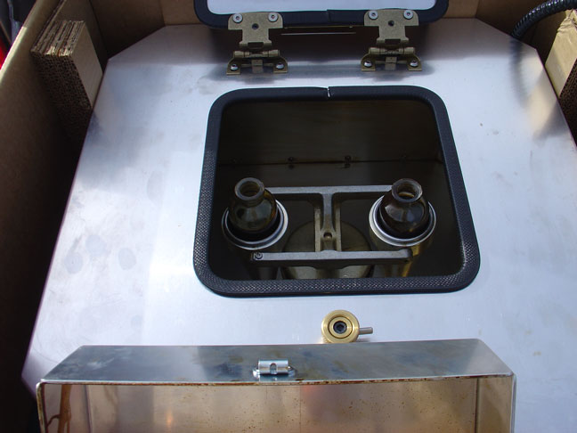
Figure 10- Well samples being centrifuged for Red Eye 2G calibration

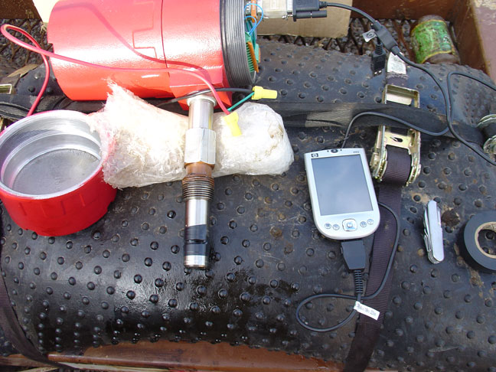

Figure 11- Spare RedEye2G, PDA and electrical tape used in PWT field calibrations

7. Unit SETUP and mobility
Figures 12- 14 show the unit moving in to the field, during the test, after the test, and being readied to move out. The unit must be set within 15 ft of the connection point due to hose length. Shorter hose lengths would allow easier setup and handling but limit the connection range. Set up time was dependent on the connection type required at the well. The unit had tapered union connections, but many wells had no unions or had flat union connections, which required special plumbing. Normal move-in/ setup and teardown/ move-out times were about 15 minutes each with plumbing changes- or 10 minutes where properly plumbed. An ideal set up for portable testing at the wellhead is shown in Figure 15. This is valid for any type of lift system. Figure 16 shows a typical centralized header where multiple wells come in and are directed to a test point or common separator.

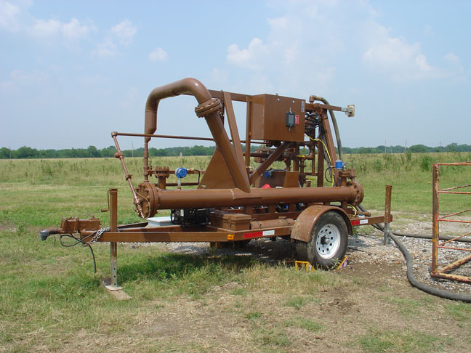

Figure 12- Portable Well tester in transport mode

Figure 13- Portable Well tester in test mode and connected to ESP well

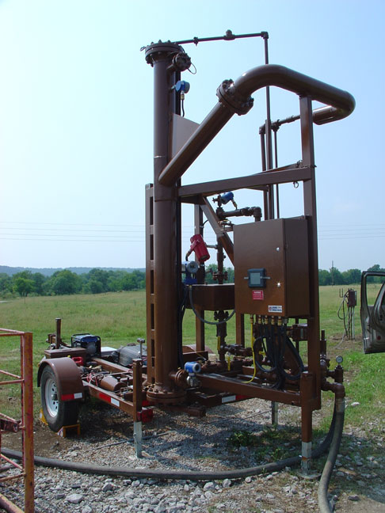

Figure 14- close up of portable well tester in test mode

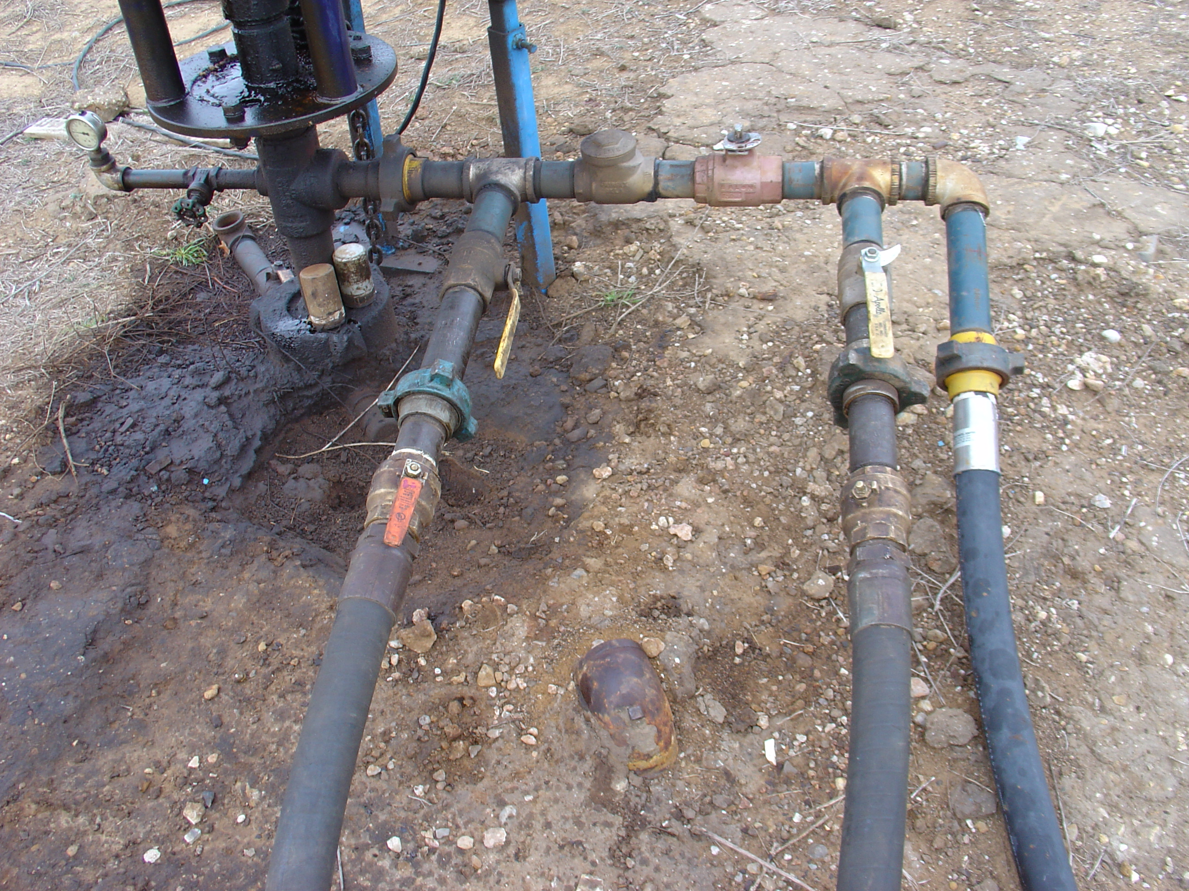

Figure 15- Ideal test header setup at the wellhead
PWT Inflow (left line), center isolation valve, PWT outflow (center line), flowline (right line)

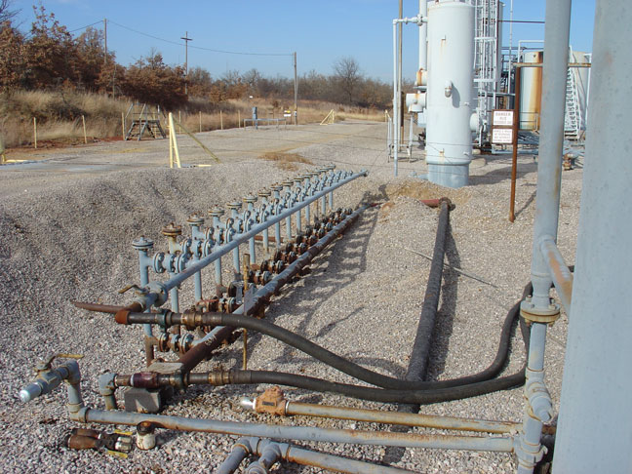
Figure 16 - Central header setup- bottom line for separation, top for testing

Well test information was obtained from the PWT by several means:
- Instantaneous readings at a given point in time by visual readings of the RTU and equipment transmitters;
- Planned Tests over a specific time period providing an averaged Test Results of rates, watercuts, pressure, temperature and other information;
- Modbus logged information obtained by connecting the RTU to a laptop computer for a limited period of time (5 minutes to 6 hours).
- For future use of the PWT, a local storage device to record key data and time dependent data must be employed until adequate wireless connections to the internet are available. This step will require onsite retrieval of that data and transmission for processing.

The basic well test procedure was as follows:
- Operator well test information was obtained where possible before moving onto wellsite;
- Crude oil and water samples from the tank battery and wells were obtained ahead of time where possible;
- The crude oil was centrifuged to ensure dry oil;
- RedEye 2G calibrations were obtained on the collected oil and water samples;
- The calibration data was entered into and stored in the PWT’s RE2G as a specified well number;
- The PWT was mobilized and moved to the well site. The back of the PWT trailer was positioned within 15 ft of the connection point /wellhead/ header;
- Trailer wheel chocks were placed on both sides of the trailer tires;
- Trailer support legs were extended and the trailer leveled;
- The wellhead pressure was noted;
- The well was shut in and required flowline valves closed;
- The wellhead connections were made, sometimes requiring breaking open an existing union and plumbing new unions for connecting the PWT;
- The PWT was set up into test mode by use of hydraulic lifts and trailer supports into a vertical position;
- Hoses were run and the PWT was connected to the wellhead;
- Flowline valves were opened, PWT valves were opened (in bypass mode normally);
- The well was turned back on. With PWT inlet pressure noted. From movein to this flow point, normally 15 minutes was required- less if wellhead connections already provided for testing;
- PWT pressure was allowed to stabilize before any other changes were made;
- Valves into the GLCC were opened;
- Bypass valves (around the GLCC) were slowly closed and inlet PWT pressure monitored;
- The PWT power was turned on and the readings were monitored for the GLCC level to stabilize. Adjustments were made as needed in PID controls;
- Ethernet wire was connected to the laptop for logging Modbus data (if desired);
- A full RTU Test was initialized for a set period of time and for a specific well calibration;
- Instant readings of the RTU and RedEye and vortex meter, plus pressure and temperature were made;
- The unit was left in test mode for the set test period and the Test ended providing Test Results which were read off the RTU;
- Modbus logging was ended if desired or continued if a variable was changed and additional information was desired;
- For GLCC bypass testing, the valve between the GLCC inlet and the liquid leg inlet was opened, the valve between the GLCC base outlet and liquid leg inlet was closed, inlet GLCC valve was closed. Sometimes GLCC bypass testing was performed before going into the GLCC;
- For calibration sensitivity tests, the selected RTU well number (i.e., oil calibration) was changed;
- A new Test was initiated and Modbus logging was continued, if desired;
- Upon the end of testing for the current well, the steps identified in 6-21 were reversed.

8. DATA COMMUNICATION

Due to the mobile nature of the PWT and potential involvement of many operators, considerable effort was dedicated to the evaluation of the data communication and operator- PWT interface. Figure 17 shows a schematic of the data communication and operator interface. Boxes 1- 4 in Figure 18 are the major points of the communication and data access. Lessons learned from operating the PWT and issues involved in data communications for the future applications are discussed in the following sections.

Boxes 1 and 2 are the two major interfaces between the operator and the metering system. Physically, box 1 consisted of a touch screen RTU (remote terminal unit). The RTU provided local links to various devices used by the PWT as well as the control for operational parameters. Figure 17 shows the various control capabilities available with the touch screen panel. The RTU provided capability to configure parameters for up to 20 wells. The RTU had very adequate built in capabilities and easy enough to navigate through if operator is given training. One of the major deficiencies of the system was the inability for the operator to read the screen when strong sunlight is present. The black and white LCD screen used in the RTU has to be shaded in order to be legible. Eventually a “home made” umbrella was devised to address this problem, but this is a major inconvenience in the field.

Box 2 is the interface between the operator and the 2G RedEye™ water cut meter for periodic field calibration of the unit. This communication is accomplished by proprietary software provided by EP Solutions, which operates in Windows CE™ environment. This software has a “configuration manager” for uploading and downloading fluid property parameters for configuring and calibrating the 2G water cut meter described in section 6. The process requires the availability of a Laptop or a pocket PC (with Windows CE™). This process requires the operator to have a pocket PC and be literate in operating the device – i.e. additional cost and training involved. Since the periodic calibration is one of the routine functions when moving from one field to another, this process must be addressed in future design and selection of the water cut meters.

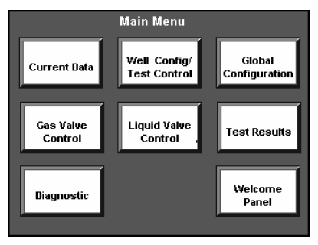
Figure 17- Main menus available on the RTU touch screen

Box 3 in Figure 18 shows schematically the method used in the current field tests to obtain time based flow rates, WC, temperature, pressure and other parametric data collected by the RTU. In the current field tests the data polling was done by a laptop computer using a MODBUS polling software. The data collected by this process must then be converted into a MS Excel format, for ease of analysis. This process is very time consuming and cumbersome. A more convenient and efficient method of converting the data must be devised in the next phase 2 of the project. The operator can of course read instantaneous and average Test Results data from the RTU screen and manually record the process. However, the continuous time-based data recording is desirable for diagnostic purpose as will be illustrated in the section on “Analysis of Field Tests” and seen in Appendix B of this report.

Box 4 shows schematically an alternative and more desirable method of polling data remotely. This alternative method was deemed necessary as we anticipate that PWT will be used in remote areas with operators who may not be skilled or not have access to laptops needed to locally poll data as described in Box 3. The RTU provided by eProduction Solution was equipped with the capability for remote polling using internet and CDMA protocol. This process/ procedure required subscription to a CDMA service. In practice we discovered that most commercial CDMA -internet providers - i.e. Verizon, AT&T, NEXTEL, others - do not provide the services outside populated areas -even though they advertise the service. Other methods of remote internet polling were investigated but these methods either lacked band width or were found to be expensive (e.g., satellite services). For future PWT applications, and until we find an internet provider with broad coverage, a local recorder incorporated in the PWT may be the best approach for collecting time based data.


RTU - PWT DATA
CS7X
192.168.10.80
COM 2
RS-232

CDMA??
BOX 1-OIC - operator interface control panel
192.168.10.20: Port 99
COM 4
RS-232
Ethernet
Port
CDMA radio address: 166.149.8.145:502
BOX 3 Field Data Polling ( ModPol)
192.168.10. 90:502
Ethernet Cable
Internet
COM 1
RS-485
Redline - address 49
BOX 2 RedEye Calibration
192.168.10.80
BOX 4 Office Data Polling (ModPol)
192.168.10.80

Figure 18
9. Field Tests – General Observations

Field tests were conducted to investigate the impact of the following parameters on the accuracy of the measurements:
- Determine the normal behavior of wells
- Flow Rate on performance and accuracy of rate and water cuts
- Lift methods affect on the flow rate
- Gas content in the well stream on both rate and water cut
- Changes in oil and water properties- gravity and salinity
- Determine the ease of use of PWT

Tests were taken on wells pumped by Electrical Submersible Pumps(ESP), Beam Pump Jacks (Beam), Progressive Cavity Pumps (PCP) and on one waterflood injection well (WIW). Rates tested were from below 100 to above 1500 BPD. Most all water cuts were above 80%, in fact most were above 95% watercut. Photographs of the PWT with these type lift wells are available on the www.impact2u.com/projects website.

Table 1 was a general summary of Test Results and Instant readings information compiled from the PWT activities. Appendix A contains a detailed activity listing of Test Result data and Instant Readings. Appendix B contains detailed Modbus data for each tested well. Detailed raw Modbus logged data are available at the www.impact2u.com/projects website. Examples and a discussion of these test findings of this study are given below and in the following sections.

A general overview of this data in Appendix B shows that well production rate and watercut varies substantially over just a few hours and over a full day without any changes in the surface Tester. Thus the timing and length of taking a well test can make a difference on the results obtained.

Also from these plots in Appendix B, several wells had substantial variations in the pump rate. Note that the inlet of the PWT has a check valve, thus the rate can go to zero, but not negative. On beam units this high variation (especially down to zero) may be due to pumping only ½ of the overall cycle, gas in the tubing, leaking standing valve or small tubing leak. On PCPs this may be due to rotor-stator (elastomer) bind-release cycles. Rate variation was usually more pronounced while bypassing the GLCC than while going through the GLCC (discussed later). Note that rates of less than about 80 BPD may not be accurately measured due to the lower limit of the Coriolis meter specified for the PWT (see Table 2). This low end rate impacted smaller beam units particularly hard.

Modbus plots (Appendix B) for wells U37, P51 and P24 are also informative for observing the effects of the GLCC Bypass and varying oil calibrations

The interesting plot of well P61’s modbus data (found in Appendix B) shows the well “pumping off”. This is a condition where the formation flow into the well is less than the pump rate out of the well and therefore the downhole pump cannot pump its full amount. The operator did have the well on timer, but this plot clearly shows that the well pumps off in less than 2 hours, not the 6 hours set in the timer.

Problems encountered in the field included erroneous RE2G readings due to dark brown spots on the RE2G internal lens. This caused the RE2G to read much lower water cuts than seen in actual sampling. This occurred temporarily on wells US18 and US232 and UWB10. Communications with eProd indicated that this was a rare occurance.

The RTU froze up on several occasions, normally when there was humidity, mist or rain in the air. This occurred on wells P61, UWB10 and others. This stopped the test but did not impact Modbus readings; however under such conditions, opening the RTU to connect the laptop was problematic.

The field input of oil/ water calibration numbers into the RE2G required opening up the back /top of the RE2G, exposing it to the elements and connecting a PDA to it for a period of time. This cannot / should not be done in misting or rain conditions, thus limiting usability of the equipment and procedure.

Low voltage caused problems early on until a low voltage sensor was installed to shut down power at 80% charge.

In a number of occurrences, the nitrogen gas bottle volume proved inadequate for liquid displacements out of the GLCC and unit for preparing the PWT for transportation.

RTU display was inadequate for high sun light conditions such that the output could not be read. A temporary plastic cover over the full RTU was utilized to enable reading of the display.

Use of a laptop computer in the field is not recommended due to cost, rain, dust, spills and other problems. Both a PDA and a Laptop computer were utilized in these tests, increasing cost and risk. Several wireless communication systems were investigated but none found adequate enough to implement. Options for RTU storage of key and time dependent data will be considered for future work as well as watching wireless capabilities.

The low end of the specified gas meter had too high a rate, thus missing the rate conditions seen in most well tests. It should be noted that all meters have specific ranges that they can operate accurately. It is desireable to measure these low gas rates and this issue needs to be directly addressed in the next project.

The RedEye2G was found to be sensitive to different produced water calibrations. This fact was not discovered until late in the testing program. It must be taken into account in future testing.

The Foxboro Coriolis meter’s transmitter has an internal fuse that is not field replaceable. This caused some loss in time for repair. Foxboro says that future versions will be field repairable.

Modbus is too clumsy a program (for direct use) in obtaining, compiling and evaluating the test data in ‘real time’ or even in post analayis. Too many windows must be opened to properly access the full range of data required for analysis.- see section 8 for more detailed discussion.

10. aNALYSIs OF FIELD TESTS

In evaluating and analyzing this testing work, we were looking to determine:
- Flow rate accuracy and repeatability;
- Watercut (WC) accuracy and repeatability;
- WC accuracy andI immpact of fluid properties and RE2G calibration on WC measurements;
- Impact ofGVF and GLCC (through GLCC versus GLCC Bypass) on rate and WC;impact
- Operating controls on GLCC; and
- Estimate the number/percent of well requiring GLCC use in the future.

This analysis will be based on the data provided in Table1, Appendices A and B and at the website www.impact2u.com/projects .

Also, Appendix C shows a table with various RedEye calibrations used in the project. Such variation was utilized to show the WC sensitivity to specific fluids. On a given well/ well stream, a calibration change was implemented by simply starting a test with a new RTU/RE2G “well number”.

Appendix D shows the number of tests used to verify the accuracy of the RedEye2G in measuring watercut on a number of wells. This was done by utilizing the 500ml sampling technique (“grab samples”) with the instantaneous RE2G reading and/or the timed Modbus RE2G data and/or the Test Result (average) data. Figure 19 shows this data plotted as RE2G water cut versus Sample watercut and Operator reported watercuts versus sample watercuts. This plot shows some scatter, especially for the RE2G, but overall reasonable match to the sampling. See later discussion below on RE2G water calibration. It should be noted that 500ml sampling is not the best method to determine the exact cut. Larger sampling (i.e., 500bbls frac tanks with pumps and gauge lines) would yield a more accurate result for a specific time, but is not practical for the number of well tested herein and their high production volume rates.

A plot of PWT flow rate versus operator furnished rate data can be seen in Figure 20. This plot generally shows an average error/ difference of less than 10%, with only a few low rate exceptions. Thus what the operators were doing is not too far off the accuracy requirements.

Figure 21 shows the PWT water cut plotted versus the Operator’s stated water cut values. Again this shows the operator’s knowledge of their wells, since test data is normally modified with field experience.

Portable field testing can be made much easier and cheaper if the GLCC separator is not needed in field testing. The impact requiring evaluation is on the average rate (not the rate variation) and on the average water cut measurement. To that end, Appendix E contains the data and Figure 22 shows a plot of the % rate difference caused by not using the GLCC versus the PWT rate data while going through the GLCC. This figure shows that inaccuracy occurs when the GLCC is bypassed in only six (6) tests. Identification of these wells in the future is paramount to the next phase of this work.

Figure 23 shows the impact of bypassing the GLCC on the PWT WC measurements. This data shows good overall agreement and little impact is seen due to bypassing the GLCC- with only 6 points outside of a 3% window of accuracy. The cause of these inaccurate points is important and will be investigated further in the next phase of testing.

Thus Figures 22 and 23 from data in Appendices D and E show that most wells in the Mid-Continent that are on artificial lift, with the tubing inlet below the perforations (normally true) and with no packer or annulus obstructions (normally true) do not need a GLCC separator for testing. This is because the well annulus serves as an initial separator of the gas and liquids- and normally does a very good job of it!

Portable field testing can also be much easier if oil calibration sensitivity is NOT a major concern to WC accuracy. Figure 24 shows the difference in WC measurements from the RE2G due only to online changes in oil calibrations used for the same well stream. The % difference plotted is (Actual calib WC– Other calib WC)/Actual calibration WC for a given well. The ‘actual calibration WC’ in these cases is the actual well’s calibration or the Tank Battery’s mixed oil calibration. Mostly, good agreement is found with only 2 points outside of a 3% accuracy level, and 6 points/tests outside of a 1% accuracy level. As this data shows, this number of RE2G re-calibrations used in this study on specific oils in a field or region may not be needed in the future.

As a note, the RE2G was selected for this project because it was NOT supposed to be mostly insensitive to changes in water properties, but a 2% WC change was seen between the original tap water calibration used for most tests and the injected waters found in well PS5 WIW during a test conducted late in the testing session. It was verified again on PW6 testing and in the C576 tests. This sensitivity was discovered too late to make a full evaluation of its impact on WC accuracy. It will be studied further in future work.

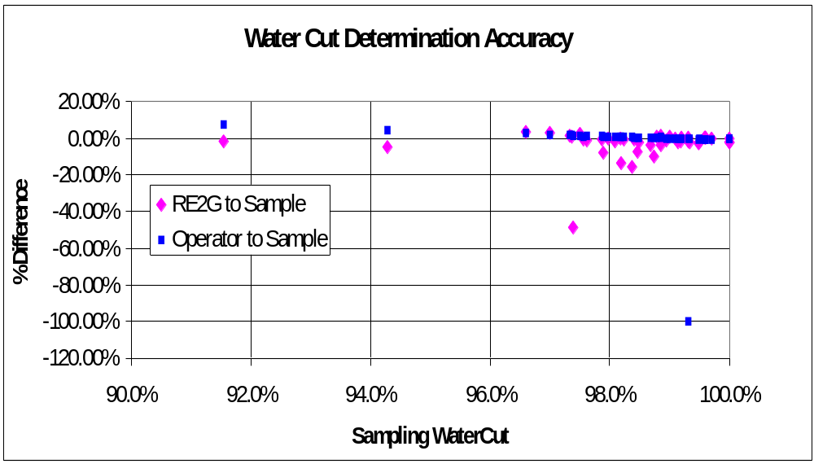

Figure 19- Comparison of Operator’s Reported WaterCuts and RE2G to 500ml Grab Samples

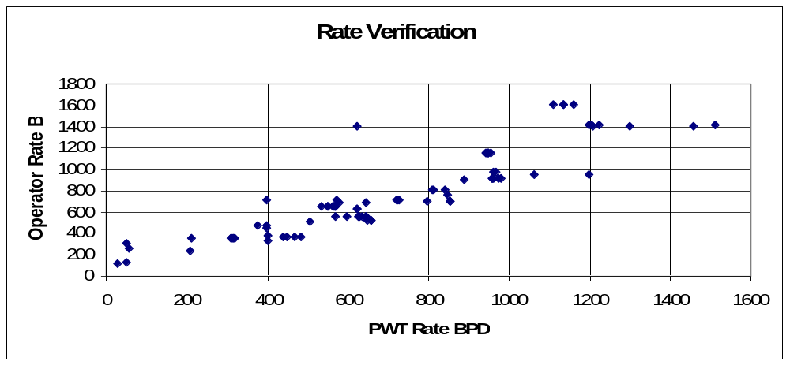

Figure 20- PWT Rate versus Operator Rate

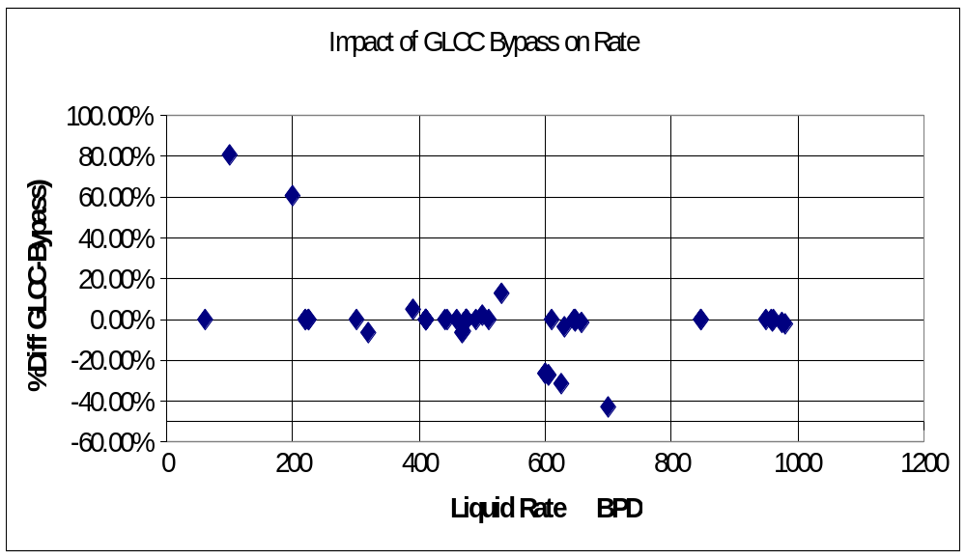
Figure 22- Impact of GLCC Bypass on the Averaged Liquid Rate (%Difference=(GLCC rate-Bypass rate)/GLCC rate)

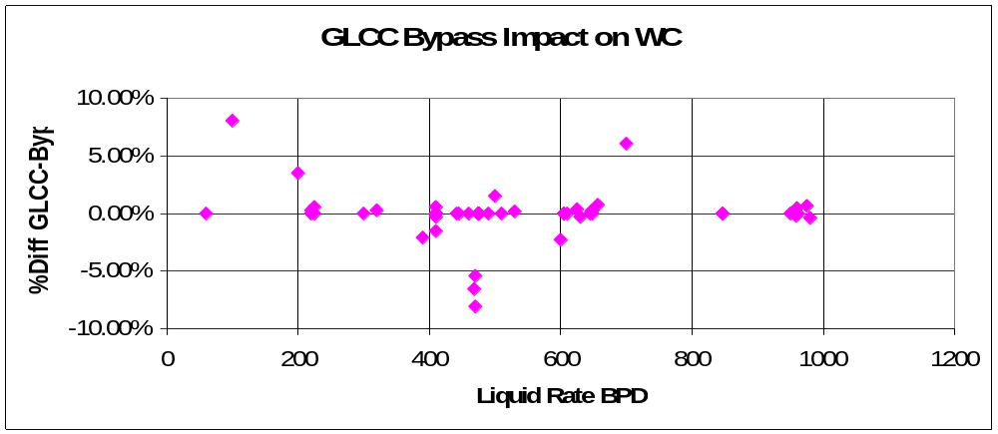

Figure 23- Impact of GLCC Bypass on the Averaged Water Cut (%Difference=(GLCC WC-Bypass WC)/GLCC WC)

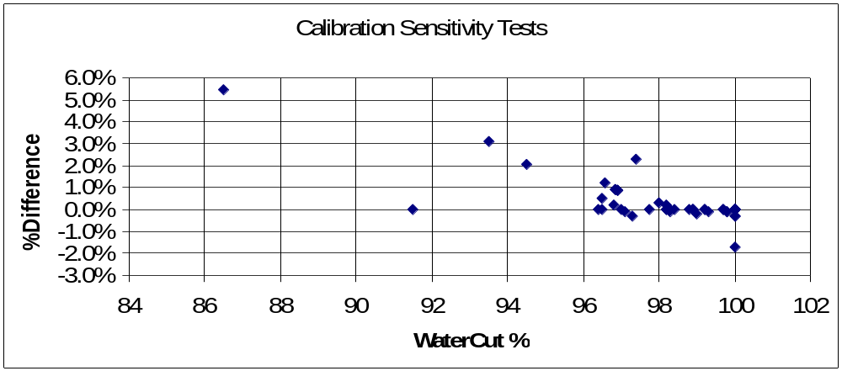

Figure 24- Sensitivity tests of Oil Calibration on Well Stream calculated Water Cut values

11 - CONCLUSIONS

The work conducted in the project has delineated a number of benefits, limitations and issues that need to be addressed in any future PWT projects. These findings were the major objectives of this project. A number of these items were discussed in earlier sections 9 and 10 of this report. The testing found:
- The eProduction Solutions’ RedEye 2G was not as sensitive to oil calibration as expected and its accuracy was better than the 3% specified by the manufacturer. The unit was found to be durable and rugged for portable use. However, only wells producing in excess of 95% water were targeted in this project.
- Contrary to the manufacturer, the RE2G was found to be sensitive to water properties and this fact must be investigated further for its impact on accuracy. This fact also means that calibration is more difficult and the RTU programming must be changed to accommodate additional calibration registers by well.
- The Foxboro Coriolis meter was found to be accurate over its full range and durable/rugged for portable testing. However, measuring rates lower than 100BPD is important for many beam pumped wells and smaller meters should be considered. A field replaceable fuse would save weeks of downtime.
- The Foxboro shedding Vortex gas meter provided weeks of problems in set up with the RTU. Once properly connected it worked satisfactorily. Its low end rate range was too high for most wells tested in this project.
- A better proving method and system for all Rate and WC meters is required to reduce time required for verification of accuracy.
- A generator is normally required for continued field use since field electric is limited for recharging batteries. Low voltage protection is required for these sensitive instruments.
- No GLCC separator is needed for testing of most MidContinent wells on artificial lift, that have the tubing below the perforations, no annular blockage and a low fluid level. The well provides sufficient separation.
- Data acquisition of time dependent values using Modbus (directly) is difficult, time consuming and should be avoided at all cost.
- Opening instruments in the field for making calibrations and connections is a major limitation due to dust and moisture.
- LCD displays are not best for high sunlight environments.
- Knowing that only 1% change in watercut can make the economic difference in profit or loss for a high volume, high water cut stripper well, it is still doubtful that the watercut measurements can be accurate enough to provide a high level of confidence in the test results. Inclusion of water calibration and better analysis of gas content may provide the answer to this remaining question.

With the above known, the way forward to improve use, efficiency and accuracy of future PWTs can be outlined:

- Provide an in-situ calibrate method on all PWTs by design of the plumbing around any WC instrument.

- The impact of water calibration on the RE2G must be quantified. If both oil and water calibrations are needed, this makes the calibration process doubly hard since 2 calibrations must be made and entered and there is only one well register for calibration in the RTU and RE2G.

- Investigate other watercut meters that are not as sensitive to fluid properties.

- No instrument should be opened in the field due to dust and moisture concerns. All connections and data acquisition ports should be on the box, visual or wireless.

- All field changes in the instruments must be by laptop or PDA and not both. PDA preferred for all input, controls and data acquisitions.

- Delete the GLCC from most wells unless a gas problem is identified beforehand. Provide a compact coriolis meter with WC determination to determine gas content by density methods. This will “red flag” problem wells or problem tests for reassessment of accuracy. This simple change will vastly lower Tester cost, weight, clearances (top and bottom) and provide for an easier setup.

- Lower cost liquid and gas meters should be used with online watercut measurements to lower the cost of PWTs. Use of turbine or PDMs should be investigated.

- Data acquisition from the RTU to the office for realtime monitoring and quick evaluation is important and can be short cutted by wireless means. Until Cell coverage improves and/or satellite cost decrease, a data storage device (flash) should be in the RTu for retrieval and transporting to a site for evaluation. Realtime monitoring and control is lost .

- Operator C’s predecessor in field C57 had earlier utilized a GLCC and Micromotion Coriolis meters in their field testing, but encountered problems severe enough to discard that equipment. It will be the first goal of the next testing Project to investigate their earlier work and overcome these problems.

12- REFERENCES

- Oak Progress Report 1 to SWC
- Oak Progress Report 2 to SWC
- Oak Presentations to SWC
- www.impact2u.com website

3- ACKNOWLEDGEMENTS

Oak Resources and Production Technology wish to express thanks to the Stripper Well Consortium, Penn State University and the US Department of Energy for their encouragement and financial support. We also wish to thank to the following companies and individuals for their effort in making this project possible.

- Uplands Resources LLC, Tulsa OK- Brian Bingman, Eddie Shoopman
- Phoenix PetroCorp, Dallas TX- Jim Williams, Mark Wilson, Eddie Clubb
- Calumet Operating Company, Tulsa OK- David Spencer, Roger Watkins
- Impact Technologies LLC, Tulsa OK- Pat Oglesby
- Impact Construction LLC, Tulsa OK- Matt Mize
- Triple D Operating Co., Ardmore OK- Tom Dunlop, Hubert Harris
- Chaston Oil and Gas, Ardmore OK- Kermit McKinney
- eProduction Solutions/ A Weatherford Company, Houston TX- Joel Rogers, Ahsan Ali, Asher Imam, Bob Wylie, Jide Adejuyigbe, Sam Suri.

11- Appendices

A. Summary Table of detailed Tester activities for all wells.
B. Individual Well Plots of Modbus data
C. Table of all Calibrations used in the testing
D. Table of RE2G readings versus sampling WC values
E. Table of Rate and WC readings with and without GLCC
F. Table of variable Calibrations Impact on WC readings

